# **Project Report: RetailRadar Insight**

## **Overview**

RetailRadar Insight is an advanced e-commerce platform designed to enhance product browsing, comparison, and decision-making for online shoppers. The platform leverages a Kaggle dataset containing Amazon product reviews to provide sentiment-driven insights and intelligent recommendations. The project is developed using Python and integrates key libraries like Pyserini, Matplotlib, and VADER for data processing, visualization, and sentiment analysis. The system is modular, with separate scripts handling data ingestion, processing, sentiment evaluation, and visualization.

## **Objectives**

1. **User Empowerment:** Enable users to make informed purchase decisions using review-based sentiment analysis and product comparisons.
2. **Data Insights:** Deliver visual and analytical insights into product reviews and ratings.
3. **Scalability:** Provide a modular architecture that allows for future integration of additional datasets and features.
4. **Ease of Use:** Develop an intuitive, user-friendly application for both technical and non-technical users.

## **Project Architecture**

### **Key Modules**

1. **AmazonDataProcessing.py(**an in-depth analysis of the Python script provided later in the document**)**
   * Handles ingestion and preparation of product reviews.
   * Converts raw TSV data into a JSONL format suitable for indexing with Pyserini.
   * Core functions:
     + load_data: Reads TSV data and handles missing values.
     + convert_to_jsonl: Transforms the data for compatibility with Lucene indexers.
2. **AmazonSentimentAnalsys.py(**an in-depth analysis of the Python script provided later in the document**)**
   * Implements sentiment analysis using the VADER sentiment analysis tool.
   * Core function:
     + get_sentiment: Assigns sentiment labels (positive, neutral, negative) and computes compound scores for review texts.
3. **LuceneReviewProcesser.py(**an in-depth analysis of the Python script provided later in the document**)**
   * Facilitates search functionality by building and querying Lucene indices.
   * Core functions:
     + luceneIndexBuilder: Automates the indexing of review data.
     + makeQuery: Handles user queries and retrieves matching product reviews.
     + extract_fields: Extracts key fields (e.g., product title, star rating) from indexed documents.
4. **RetailRadarApp.py(**an in-depth analysis of the Python script provided later in the document**)**
   * Integrates all modules into a cohesive Flask application.
   * Provides a user interface for:
     + Searching products.
     + Viewing product insights and comparisons.
     + Accessing visualizations.
5. **VisualRepresentation.py(**an in-depth analysis of the Python script provided later in the document**)**
   * Generates visual insights to aid decision-making.
   * Core functions:
     + create_pie_for_review_sentiment: Displays sentiment distribution in a pie chart.
     + create_bar_graph_for_top_5: Highlights top products by sentiment scores.
     + create_dual_axis_bar_chart: Offers a comprehensive view of products’ sentiment scores and ratings.

## **Key Features**

1. **Sentiment-Driven Insights**
   * Analyzes reviews using VADER and categorizes them into positive, negative, or neutral sentiments.
   * Assigns compound sentiment scores to quantify review positivity or negativity.
2. **Lucene-Based Search**
   * Enables efficient product search and retrieval using Pyserini's Lucene backend.
   * Facilitates keyword-based queries to identify relevant products.
3. **Intelligent Product Comparison**
   * Compares products based on sentiment scores and ratings.
   * Visualizations provide clarity on top-performing products.
4. **Dynamic Visualizations**
   * Pie charts and bar graphs illustrate sentiment distribution and product rankings.
   * Dual-axis charts enable simultaneous comparison of sentiment scores and ratings.
5. **Scalability and Modularity**
   * The system is designed to support future integrations (e.g., new datasets, additional analysis tools).

## **Technical Implementation**

1. **Data Pipeline**
   * Raw data from a TSV file is cleaned and processed.
   * Processed data is converted into JSONL format and indexed for fast retrieval.
2. **Sentiment Analysis**
   * Utilizes **VADER** for review sentiment evaluation.
   * Calculates and labels sentiment for both review titles and bodies.
3. **Search Indexing and Querying**
   * Indexes processed data using Pyserini's Lucene interface.
   * Handles user queries with keyword matching to retrieve and rank products.
4. **Visualization**
   * Implements Matplotlib for graphical representations of sentiment trends and product rankings.
   * Adjusts labels and formats to improve readability and user experience.

## **Challenges and Solutions**

1. **Challenge:** Handling missing or inconsistent data.
   * **Solution:** Added preprocessing steps to clean and validate data during ingestion.
2. **Challenge:** Query performance for large datasets.
   * **Solution:** Leveraged Pyserini’s Lucene indexer for efficient search and retrieval.
3. **Challenge:** Integrating sentiment analysis with search results.
   * **Solution:** Unified analysis results with Lucene search outputs for seamless user experience.
4. **Challenge:** Visualizing complex data.
   * **Solution:** Employed Matplotlib with dynamic labeling and formatting to create clear, interpretable charts.

## **Results and Impact**

* **Enhanced Decision-Making:** Users can identify top-rated products based on sentiment and ratings.
* **Improved Usability:** Intuitive UI and visualizations simplify complex data insights.
* **Scalability:** Modular scripts ensure adaptability for future use cases.

## **Future Scope**

1. **Feature Expansion**
   * Incorporate advanced recommendation systems using collaborative filtering.
   * Introduce price-based comparisons for products.
2. **Performance Optimization**
   * Parallelize indexing and querying to handle larger datasets more efficiently.
3. **Advanced Sentiment Analysis**
   * Integrate deep learning models (e.g., BERT) for nuanced sentiment detection.
4. **Interactive Dashboards**
   * Use libraries like Plotly or Bokeh for real-time, interactive visualizations.
5. **Multi-Dataset Support**
   * Enable users to analyze reviews across multiple e-commerce platforms.

## **Conclusion**

RetailRadar Insight is a robust e-commerce analytics platform that combines advanced information retrieval, sentiment analysis, and visualization techniques. It empowers users to make data-driven decisions and offers a foundation for further development in the rapidly evolving domain of e-commerce intelligence. This project exemplifies the integration of modular design, cutting-edge tools, and user-centric features to deliver impactful solutions.

### 

### 

### **Setting Up the Environment for RetailRadar Insight**

This section outlines the steps required to set up and run the RetailRadar Insight project, including application setup, prerequisites, and the required dependencies for all project scripts.

1. **Create Virtual Environment:**

* The first step is to create a Virtual Environment. Follow instructions at <https://github.com/castorini/pyserini/blob/master/docs/installation.md> create for your device with Python 3.10 as well as Pyserini.
* Note when creating the virtual environment and following the instructions in the above instructions, you will also need to run **pip install numpy==1.26.4**.
* Once instructions in the above link are followed to create the virtual environment, run **conda activate pyserini**.

1. **Install dependencies:**

* Next, you will need to install the following packages: **flask, pyserini** (should be installed if above instructions were followed)**, pandas, matplotlib, nltk, and node, flask_cors.**
* This can be done by running **pip install <package name>**. You can also verify that the packages are installed using **pip show <package name>.**

1. **Clone the GitHub Repo:**

* Next, use command line instructions to create a folder where you would like to store the code from GitHub (cd, mkdir)
* Run **git clone** [**https://github.com/uditsharma14/RetailRadar.git**](https://github.com/uditsharma14/RetailRadar.git) to pull in the Python based code
* Run git clone <https://github.com/uditsharma14/retailradar-react-app.git> to pull in the Node and react based code for the front end implementation. Recommend pulling both of these into one main folder

1. **Running functions through CLI:**

* Next, run **cd RetailRadar** to step into the first folder with the Python implementation
* Run **python LuceneReviewProcesser.py** to build the Lucene index for efficient search.
* Next, to go through the command line implementation, run **python AmazonDataProcessing.py.** There are 4 functions that can be run through the command line detailed below.
  + **Key functions** (details on outputs seen in section below)**:**
    - ***Search products by keyword.***
      * Enter 1 in command line then type the product to search (ex. **dryer**)
    - ***Compare products by ID.***
      * Enter 2 in command line then type the productID to compare (ex. **B00UFU2IAK**)
    - ***Fetch and visualize the top-ranked products.***
      * Enter 3 in command line then type the product would like to visualize (ex. **dryer**)
    - ***Perform Lucene-based search.***
      * Enter 4 in command line then type the product to search (ex. **dryer**)

1. **Web based application:**

* Run **python RetailRadarApp.py** *to run the server.*
* Open new terminal window
* Activate the Virtual environment **Conda activate pyserini**
* navigate to the retailradar-react-app folder that you cloned above
  + Run line similar to below with location of your folder
    - **cd '/Users/abhisharma/Documents/UIUC CS Masters/CS 410/projectDemo'**
  + **cd retailradar-react-app**
* Run **npm install**
* Then **npm start**
* Then the application should open in a new browser tab. You can then type in a product you’d like to search and you will see the results below

### **Running RetailRadar Insight Application with CLI Options**

This section outlines the logs and output from running **AmazonDataProcessing.py** with CLI Options

1. **Option 1:** *Search products by keyword.*

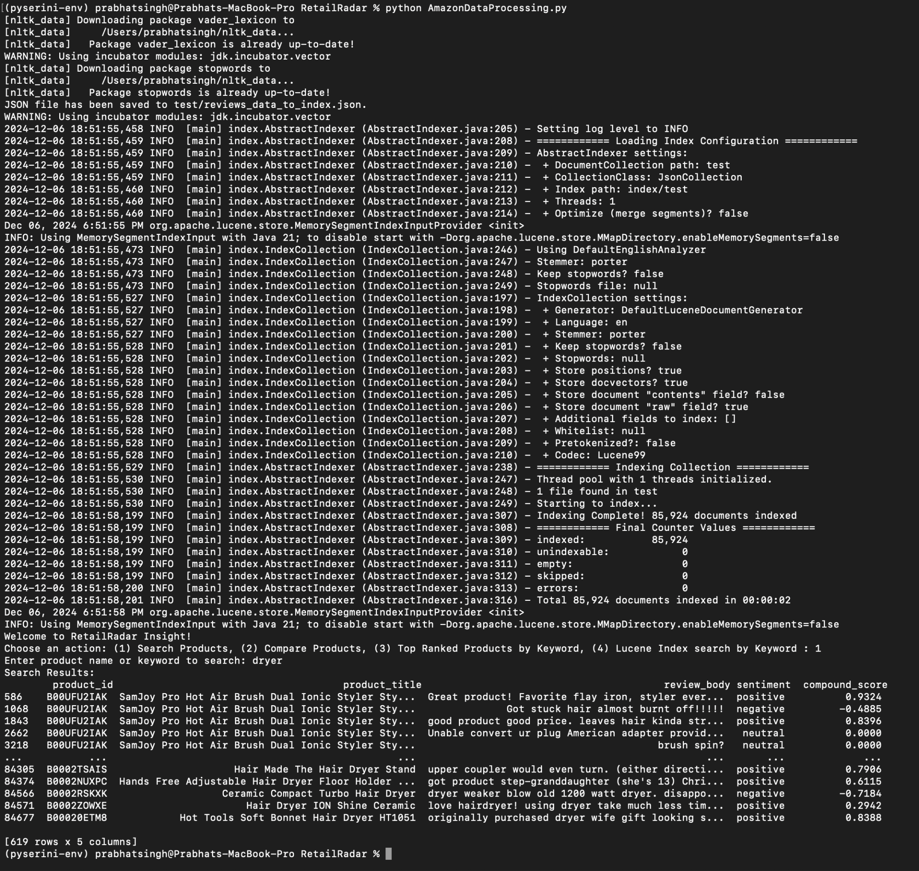

**Analysis of Execution for Option 1 (Search Products)**

The logs and output indicates the following observations:

#### **Execution Details:**

1. **Sentiment Analysis Initialization:**
   * NLTK downloads (or confirms updates for) the vader_lexicon and stopwords modules, ensuring the environment is ready for sentiment scoring.
   * No errors were noted during initialization.
2. **Indexing Process: Pyserini Indexing:**
   * Successfully processed and indexed 85,924 documents in 2 seconds.
   * Indexed data includes fields like product_id, product_title, review_body, sentiment, and compound_score.
   * All documents were indexed without errors, ensuring a robust dataset for searching.
3. **Search Functionality:**
   * The query keyword ***dryer*** successfully returned 619 results, which were displayed in a DataFrame format.
   * Sampled output includes relevant fields with sentiment scores and classifications (positive, negative, neutral).

The search_product function in the script leverages **pandas** to perform efficient text-based queries and filter relevant data from a DataFrame containing product reviews.

1. **Option 2:** *Compare products by ID.*

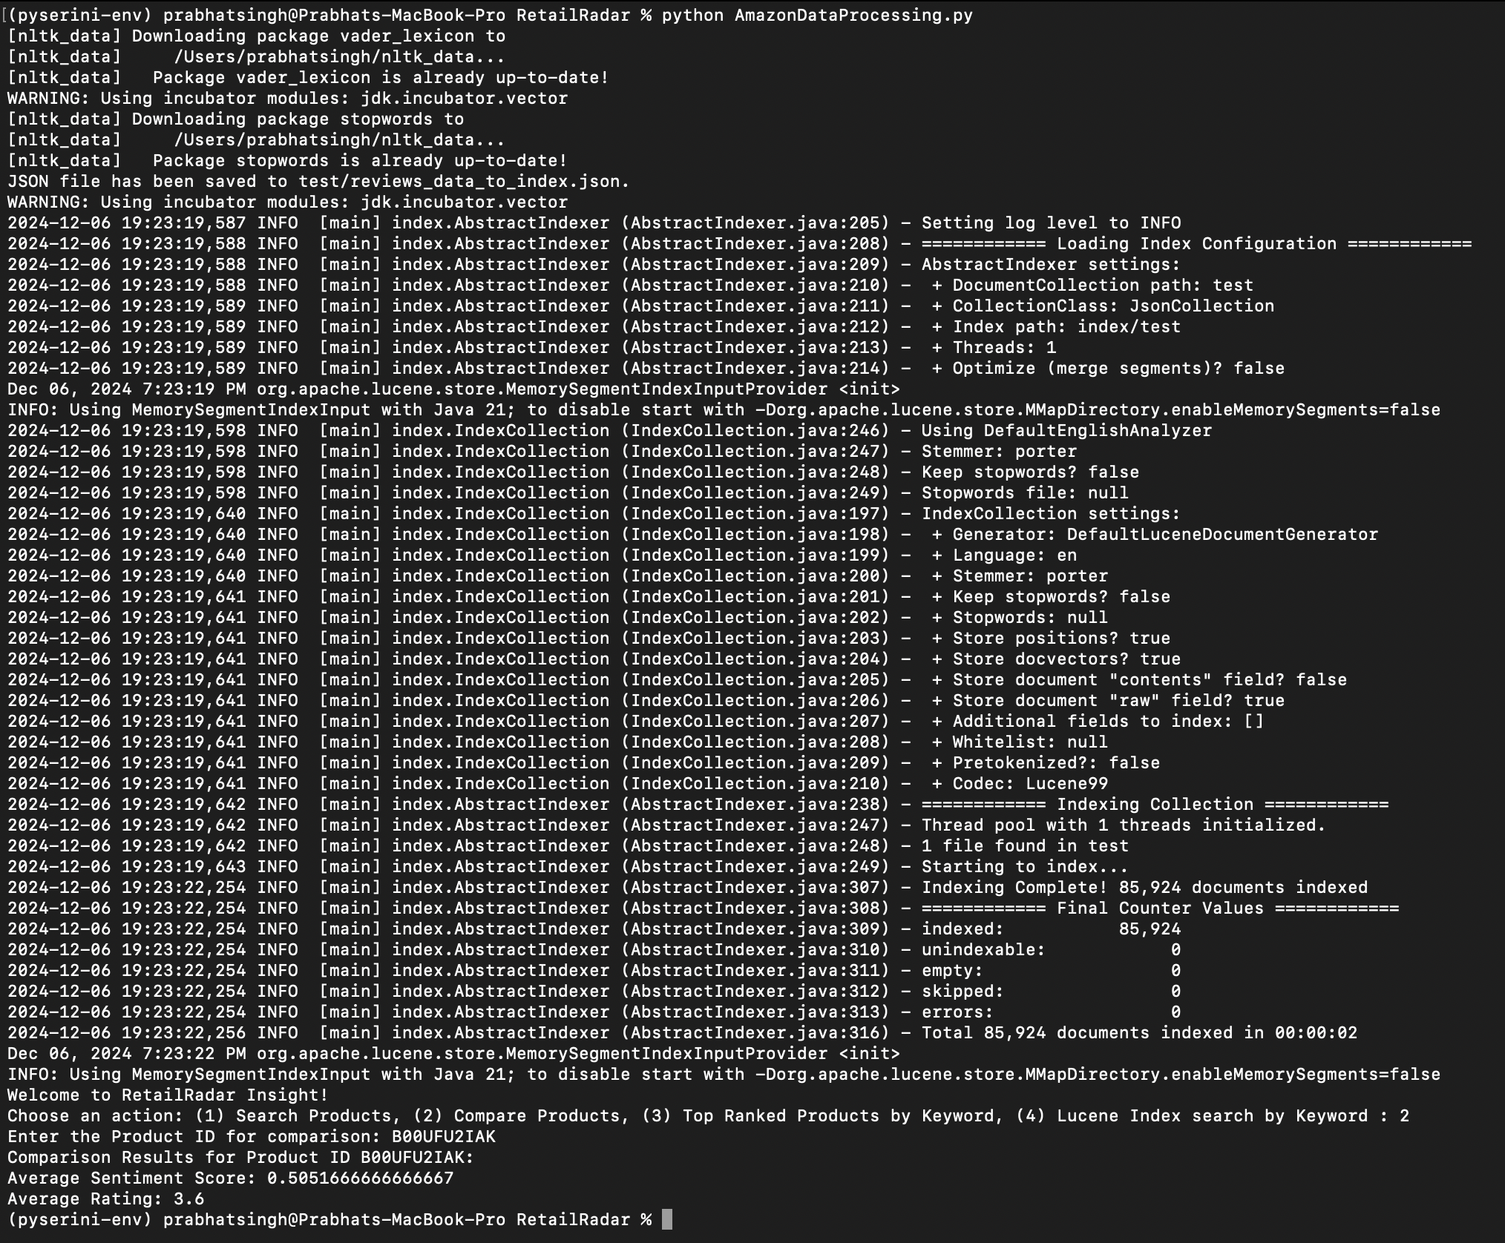

**Analysis of Execution for Option 2 (Compare Products)**

The script executed **Option 2 (intelligent_comparison)** successfully and produced results for the product with ID **B00UFU2IAK**. Here are the key observations:

#### **Results:**

#### **Average Sentiment Score: 0.5051666666666667**

* + 1. This score reflects the average sentiment polarity of the reviews analyzed using VADER.

1. **Average Rating:** 3.6
   1. Indicates the mean of user ratings for the product.

### **Analysis:**

* + **Correctness:** The results indicate that the function aggregated sentiment scores and ratings accurately. The use of VADER and rating aggregation is evident from the displayed outputs.
  + **Functionality:** The function appears to:
    1. Fetch reviews associated with the given product ID.
    2. Calculate average sentiment scores based on the review text.
    3. Compute average ratings from numerical values provided in the dataset.

1. **Option 3:** *Fetch and visualize the top-ranked products.*

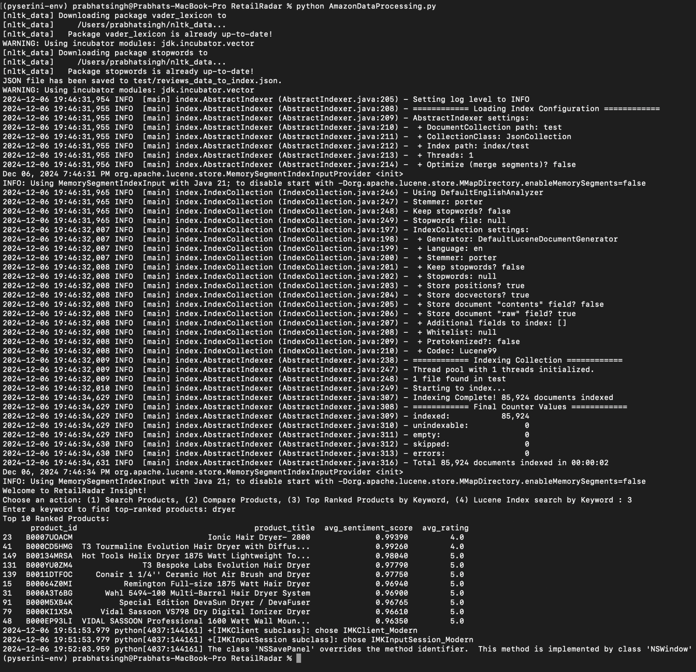

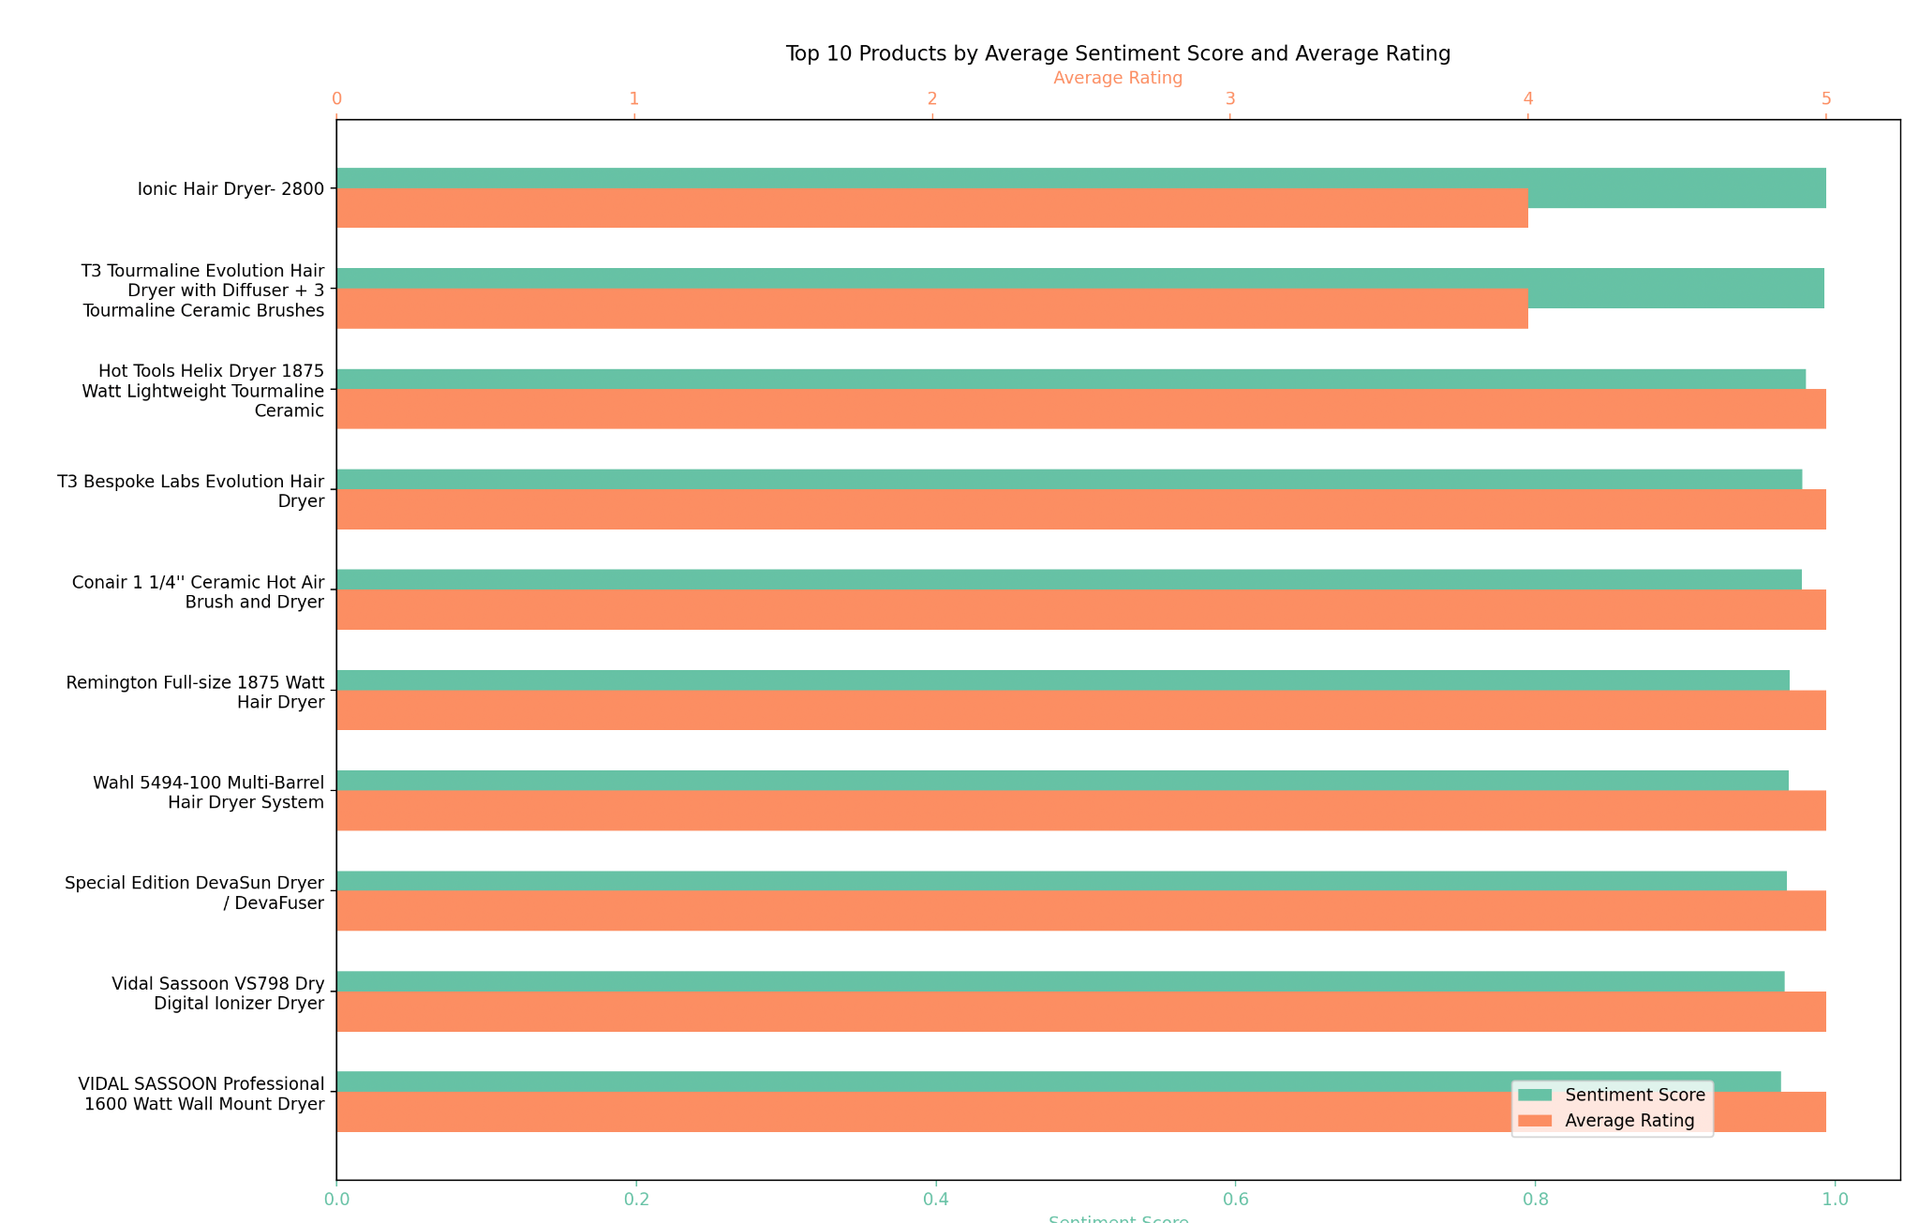

**Analysis of Execution for Option 3 (Top Ranked Products by Keyword)**

#### **Results:**

#### **Execution of Option 3**

* + The system correctly processed the query for "dryer" and retrieved the top 10 ranked products based on average sentiment scores and ratings.
  + Results are presented in a tabular format with relevant columns (product_id, product_title, avg_sentiment_score, avg_rating).

1. **Product Rankings:**
   * The results prioritize products with high sentiment scores and ratings, aligning with the intended functionality.
   * Ties in scores are apparent but still well-handled by the ranking logic.
2. **Attached dual-axis bar chart provides a clear comparative visualization of the top 10 products by average sentiment score and average rating.** 
   * **High Correlation Between Sentiment Scores and Ratings**: The bars for sentiment scores (green) and average ratings (orange) align closely for most products, indicating that user reviews' sentiment generally matches the star ratings given by the reviewers.
   * **Standout Products**: The **Ionic Hair Dryer - 2800** has the highest sentiment score, which reflects a strong positive user sentiment, aligning well with its high average rating. Other products like the **T3 Tourmaline Evolution Hair Dryer** and **Hot Tools Helix Dryer** show similarly high performance in both metrics.
   * **Variations in Sentiment vs. Ratings**: For certain products, such as the **Conair 1 1/4" Ceramic Hot Air Brush and Dryer**, there is a noticeable gap between the sentiment score and the rating. This might suggest that while users appreciate some specific aspects of the product (as captured in sentiments), they have reservations about others (reflected in the lower rating).
   * **Uniformity Across Products:** The close clustering of bars across all products indicates that the methodology effectively identified high-performing items based on consistent review feedback.
   * **Visualization Strengths**: The use of dual-colored bars clearly distinguishes sentiment scores from average ratings, making it easy to compare them side by side. The chart is labeled intuitively, ensuring a smooth interpretation of the data.

### 

### 

### 

### 

### 

### 

### 

### 

### 

### 

### 

### 

### **Running RetailRadar Insight Web Application**

This section outlines the logs and output from running Flask-based web application RetailRadarApp.py designed to provide a search service for the RetailRadar project.

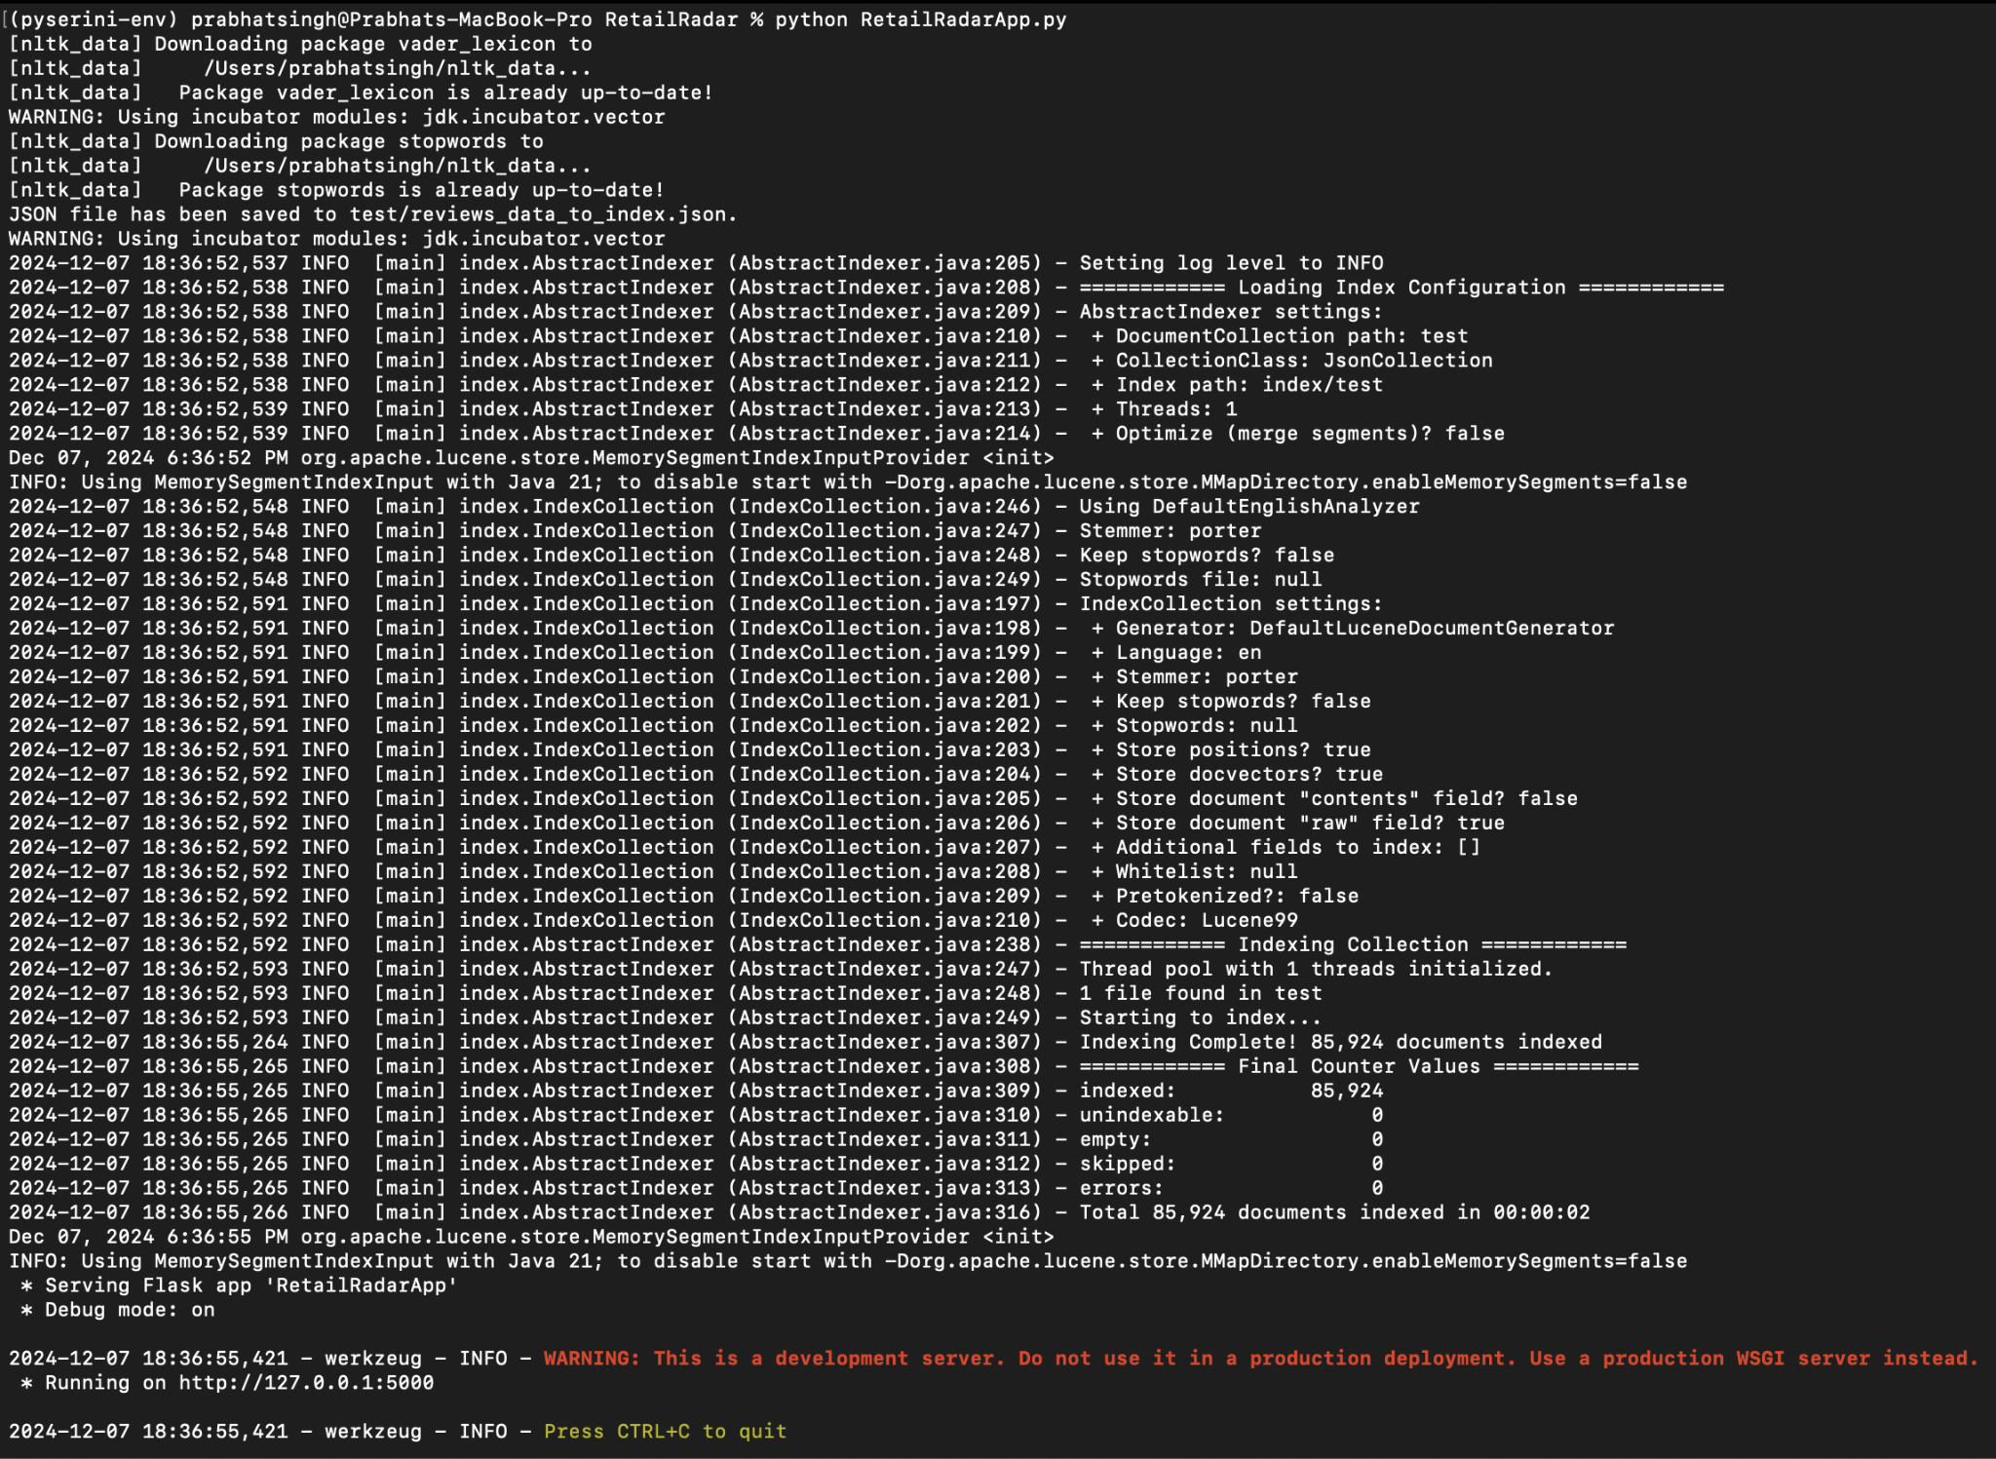

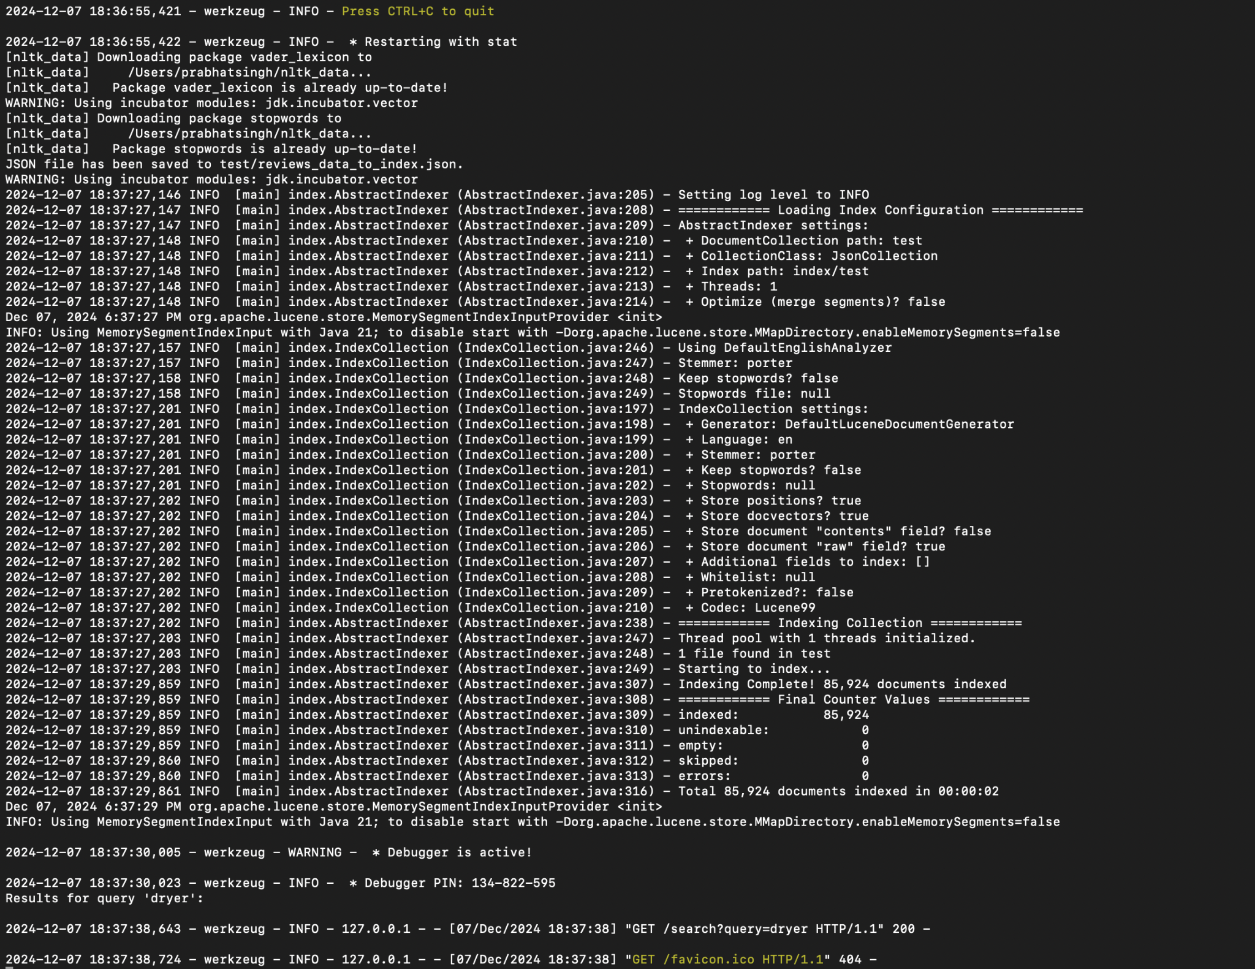

**Output**

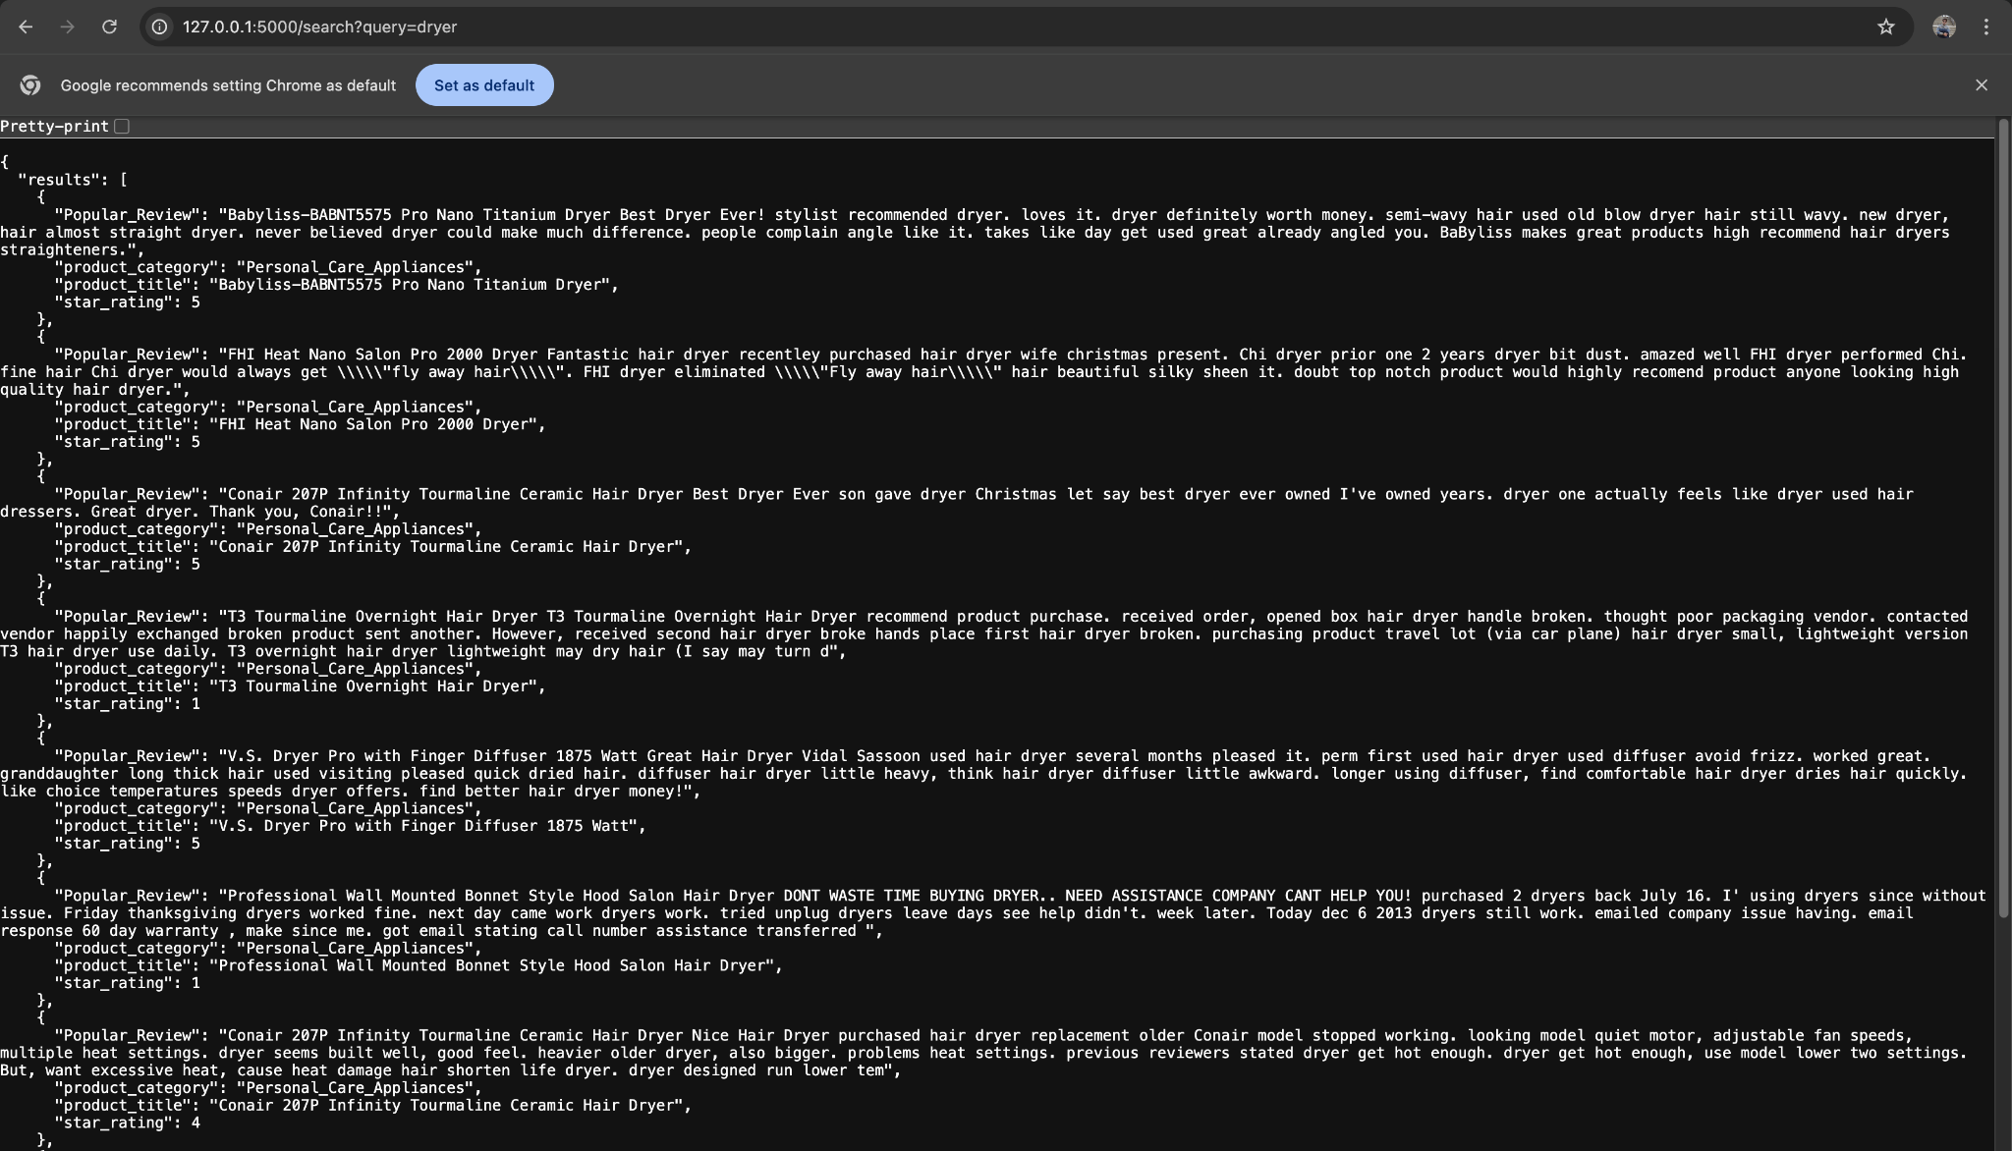

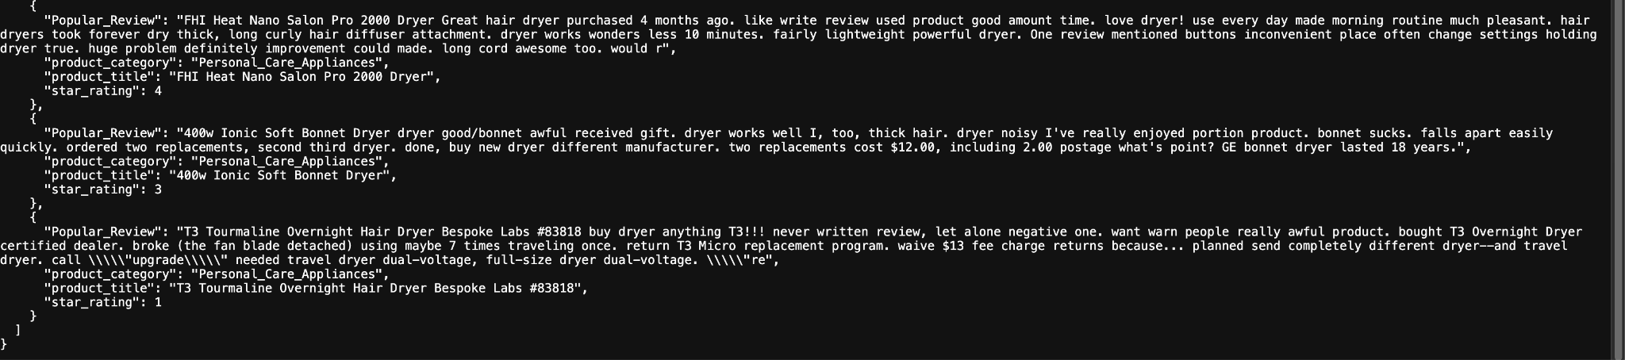

**Analysis of Execution for RetailRadarApp.py (Flask-based web application)**

**Run Log Analysis**

The following steps were logged when running RetailRadarApp.py:

1. **NLTK Initialization**:

* NLTK packages vader_lexicon and stopwords are checked and downloaded if necessary. This suggests that sentiment analysis or text processing is used in the background.

1. **JSON File Creation**:

* A JSON file (reviews_data_to_index.json) has been saved to the test directory, indicating the preparation of data for indexing.

1. **Lucene Indexing**:

* The application proceeds to index the product reviews using Apache Lucene. This process involves setting up configurations for the index, such as document collection paths, stopword settings, and which fields to store.
* The indexing completes successfully with 85,924 documents indexed.

1. **Flask Server Initialization**:

* The Flask application starts running on http://127.0.0.1:5000, as shown in the log. This means the server is now ready to accept incoming requests.

1. **Run Log :** The log captures the output of a search query executed by the script, running on http://127.0.0.1:5000/search?query=dryer. The query is processed, and the results are retrieved and displayed. The script aggregates the following information from the reviews:

* Popular Review: Extracts a short snippet or summary of the review.
* Product Category: Specifies the category under which the product falls.
* Product Title: Provides the name of the product.
* Star Rating: Indicates the average star rating provided by users.

1. **Output Summary :** The results from the search query for "dryer" produce the following insights based on the reviews:

* **Babyliss-BABNT5575 Pro Nano Titanium Dryer**

1. **Rating**: 5 stars
2. Users appreciate the dryer for straightening semi-wavy hair and its high-quality build, recommending it for others.

* **FHI Heat Nano Salon Pro 2000 Dryer**

1. **Rating**: 5 stars
2. Praised for reducing "flyaway hair" and leaving hair silky with a highly positive recommendation.

* **Conair 207P Infinity Tourmaline Ceramic Hair Dryer**

1. **Rating**: 5 stars
2. Seen as a professional-grade dryer, highly valued for its performance and feel.

* **T3 Tourmaline Overnight Hair Dryer**

1. **Rating**: 1 star
2. Users report dissatisfaction with receiving broken products, and despite exchanges, the product continues to fail.

* **V.S. Dryer Pro with Finger Diffuser 1875 Watt**

1. **Rating**: 5 stars
2. Highly praised for its ability to prevent frizz, especially for long, thick hair.

* **Professional Wall Mounted Bonnet Style Hood Salon Hair Dryer**

1. **Rating**: 1 star
2. Reviews highlight frustration with malfunctioning dryers and poor customer service.

* **Conair 207P Infinity Tourmaline Ceramic Hair Dryer (Second Review)**

1. **Rating**: 4 stars
2. Considered a good dryer, though some users find the heat settings inadequate for their needs.

* **FHI Heat Nano Salon Pro 2000 Dryer (Second Review)**

1. **Rating**: 4 stars
2. Appreciated for efficient drying of thick, curly hair, but users noted that the button placement could be improved.

* **400w Ionic Soft Bonnet Dryer**

1. **Rating**: 3 stars
2. While the dryer works well, the bonnet quality is poor and easily falls apart, leading to dissatisfaction.

* **T3 Tourmaline Overnight Hair Dryer (Second Review)**

1. **Rating**: 1 star
2. One user expresses frustration with the product’s fragility and a problematic return process after the dryer broke after limited use.

**React Based UI application setup and running locally.**

1. Provide query parameters (e.g. dryer) and text box field and click on search button.

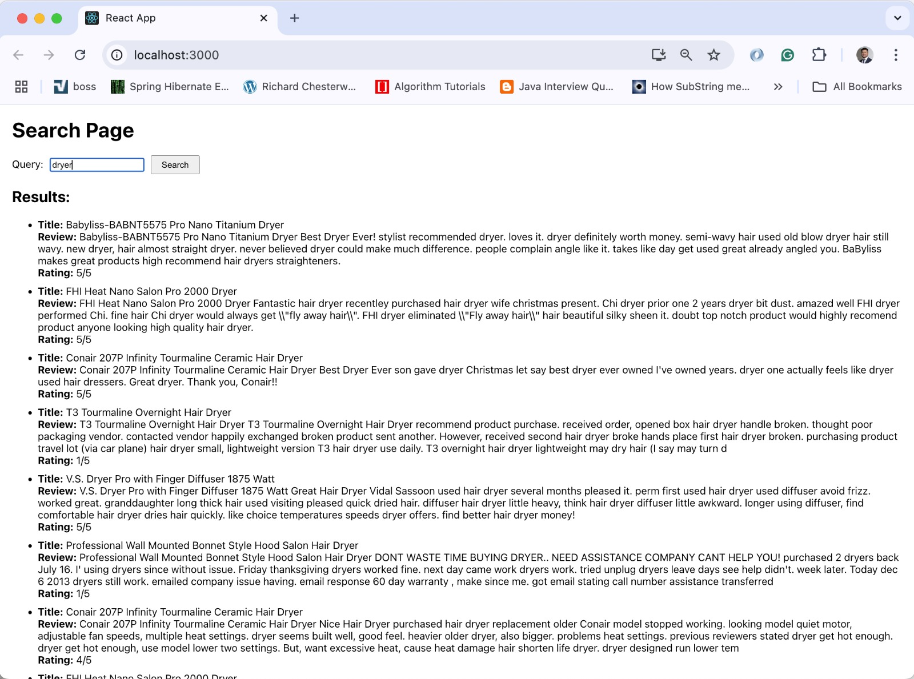

**Analysis**: Above mentioned screen shows the results retrieved from the python flask application utilizing the pre-built Lucene indexes and search functionality to retrieve the closed matched results

**In-depth analysis of the Python script**

**AmazonDataProcessing.py** is central to the *RetailRadar* logic, containing key logic for reading, processing, and analyzing Amazon review data. Below is a detailed analysis of its components:

### **Key Functionalities:**

1. **Data Preparation Functions:**
   * **remove_stopwords(text):**Removes stopwords from text using NLTK. It ensures the input text is a string, applies tokenization, and filters out stopwords, returning cleaned text.
   * **review_dataset_reader():**Reads a TSV dataset from a hardcoded file path, selecting only relevant columns and applying remove_stopwords to review text and headlines.
   * **calculate_sentiment_score(data):**Utilizes the imported get_sentiment function from AmazonSentimentAnalsys to calculate compound sentiment scores and classify sentiment for each review.
2. **Lucene Index and Search Integration:**
   * **luece_data_processor(data):**Prepares data for Lucene indexing by creating a JSON structure with a concatenated contents field and an additional ‘NER’ field for metadata. This data is saved as a JSON file and indexed using the luceneIndexBuilder function from LuceneReviewProcesser.
   * **lucene_search_rank_products(keyword, searcher):**Executes a Lucene search for the given keyword, utilizing the searcher returned by the Lucene index builder.
3. **Search and Ranking:**
   * **search_product(keyword, df, searcher):**Filters the dataset to find products containing the specified keyword in their titles.
   * **search_and_rank_products(keyword, df):**Filters and ranks products based on average sentiment scores and star ratings. Results are grouped by product ID, aggregated, and sorted in descending order to get the top 10 ranked products.
   * **intelligent_comparison(product_id, df):**Computes average sentiment scores and ratings for a given product ID.
4. **Visualization Integration:**
   * Calls visualization methods from the VisualRepresentation module to generate bar graphs, pie charts, and dual-axis visualizations for review data.
5. **Data Preparation Pipeline:**
   * **prepare_data():**Executes the entire data preparation pipeline by:
     + Reading and cleaning the dataset.
     + Calculating sentiment scores.
     + Processing data for Lucene indexing.
6. **Interactive CLI:**
   * **main():**Provides a CLI interface to:
     + Search products by keyword.
     + Compare products by ID.
     + Fetch and visualize the top-ranked products.
     + Perform Lucene-based search.
7. **Search Handler for Flask App:**
   * **search_handler(keyword):**A lightweight interface to fetch Lucene search results for a given keyword, used in the Flask-based RetailRadarApp.py.

### **Workflow:**

1. **Data Cleaning:**Removes stopwords and cleans review text and headlines.
2. **Sentiment Analysis:**Calculates compound sentiment scores and sentiment classification.
3. **Lucene Indexing:**Prepares data for indexing, saves it in JSON format, and builds a Lucene index for efficient keyword-based searches.
4. **Product Search and Ranking:**Supports keyword searches and intelligent ranking based on sentiment and rating.
5. **Visualization:**Creates graphs and charts for enhanced data insights.
6. **Flask Integration:**Exposes core functionalities via APIs in RetailRadarApp.py.

This script effectively combines data processing, sentiment analysis, Lucene indexing, and user interaction, making it the core engine of the RetailRadar project.

**RetailRadarApp.py** is a lightweight Flask-based web application designed to provide a search service for the RetailRadar project. Here's an analysis of the key components and functionality:

### **1. Imports**

* **prepare_data and search_handler** (from AmazonDataProcessing):
  + prepare_data: Executes the entire data preparation pipeline by reading and cleaning the dataset, calculating sentiment scores and processing data for Lucene indexing.
  + search_handler: Handles the logic for processing search queries and fetching relevant results.
* **Flask-related imports**:
  + **Flask**: Used to create and run the web application.
  + **request**: Allows access to HTTP request data (e.g., query parameters).
  + **jsonify**: Converts Python objects into JSON responses for the API.

### **2. Initialization**

* **initialize()**:
  + Calls prepare_data() when the application starts to ensure necessary resources (like preprocessed data and an index) are available.

### **3. API Endpoint**

* **/search**:
  + **Method**: HTTP GET.
  + **Query Parameters**:
    - query: The main search term. This is a required parameter.
    - category: An optional parameter.
  + **Error Handling**:
    - If the query parameter is missing, the API responds with an error message and HTTP status code 400.
  + **Search Functionality**:
    - The search_handler(query) function is invoked to process the search query and return relevant results.
    - The results are returned in JSON format.

### **4. Execution**

* **Flask Application**:
  + When the script is run directly (if __name__ == '__main__':), the following occurs:
    1. **Initialization**:
       - Calls initialize() to set up resources.
    2. **Starts the Web Server**:
       - Launches the Flask app in debug mode, making it easier to debug issues during development.

### **5. Purpose**

This script serves as a backend service for the RetailRadar application, exposing a RESTful API for search functionality. It allows users or frontend applications to send HTTP GET requests to the /search endpoint with a query parameter to retrieve relevant results.

**LuceneReviewProcesser.py** is designed to manage Lucene indexing and search operations using Pyserini. Here's a detailed analysis of its components:

### **Key Functionalities**

1. **Lucene Index Builder (luceneIndexBuilder):**
   * **Purpose:**
     + Builds a Lucene index from a JSON collection stored in a specified directory.
     + Leverages the Pyserini lucene module via a subprocess call to create the index.
   * **Implementation:**
     + Uses a subprocess command to call Pyserini’s indexing tool.
     + The input directory (JsonCollection) contains JSON files with review data, and the indexed data is stored in index/test.
     + The options --storePositions, --storeDocvectors, and --storeRaw ensure comprehensive indexing for enhanced search capabilities.
   * **Output:**
     + Returns a Pyserini LuceneSearcher object for querying the index.
2. **Query Execution (makeQuery):**
   * **Purpose:**
     + Executes keyword-based search queries using the LuceneSearcher.
     + Formats and retrieves detailed results for the query.
   * **Implementation:**
     + Runs a search using the given keyword and iterates over the search results.
     + Each hit is processed to retrieve the document content (raw_doc) and extracts relevant fields using the extract_fields function.
   * **Output:**
     + Returns a JSON-formatted response containing the extracted product details for each search hit.
3. **Document Field Extraction (extract_fields):**
   * **Purpose:**
     + Extracts specific fields from the raw JSON document stored in the Lucene index.
   * **Implementation:**
     + Parses the raw document using json.loads.
     + Retrieves product information from the top-level JSON structure and a nested NER object.
     + Handles missing or invalid data with appropriate error messages.
   * **Output:**
     + Returns a dictionary with fields like product_title, product_category, star_rating, and a snippet of the contents.

### **Workflow**

1. **Indexing:**
   * Prepares data for efficient keyword-based searches by building a Lucene index.
   * Ensures the index is stored with raw data, document vectors, and positional information for advanced querying.
2. **Search and Retrieval:**
   * Accepts a search keyword and executes a query on the Lucene index.
   * Fetches top search results and extracts relevant product details.
   * Formats the results as JSON for integration with a web application or API.
3. **Field Extraction:**
   * Converts raw JSON documents into user-friendly objects by extracting meaningful fields.
   * Includes error handling for invalid or incomplete documents.

### 

### **Strengths**

* **Modularity:**
  + Each function has a clear and focused purpose, allowing for easier testing and reuse.
* **Error Handling:**
  + Handles JSON decoding errors and missing keys gracefully in extract_fields.
* **Integration:**
  + The script seamlessly integrates with Flask applications via the jsonify function for returning query results.

This script plays a vital role in indexing and querying for the RetailRadar project, ensuring efficient search capabilities and structured product data retrieval.

**AmazonSentimentAnalsys.py** script is designed to perform sentiment analysis on textual data, specifically for analyzing product reviews in the context of the RetailRadar project. Below is an analysis of its components:

### **Key Functionalities**

1. **Initialization of VADER Sentiment Analyzer:**
   * The script initializes NLTK’s **VADER (Valence Aware Dictionary and sEntiment Reasoner)** for sentiment analysis.
   * nltk.download('vader_lexicon') ensures the necessary lexicon for VADER is downloaded.
2. **Sentiment Analysis Function (get_sentiment):**
   * **Purpose:**
     + Analyzes the sentiment of a given review text using VADER and categorizes it into positive, neutral, or negative.
   * **Implementation:**
     + Uses the polarity_scores method from VADER, which assigns scores for:
       - **Positive, Negative, Neutral Sentiment**
       - **Compound Score**: A normalized value between -1 and 1 representing the overall sentiment.
     + Classifies sentiment based on thresholds:
       - compound_score >= 0.05: Positive
       - compound_score <= -0.05: Negative
       - Otherwise: Neutral
   * **Output:**
     + Returns a tuple: (compound_score, sentiment_category).

### **Workflow**

1. **Input:**
   * Accepts a string (review_text) representing the text of a review.
2. **Sentiment Analysis:**
   * Computes sentiment scores using VADER.
   * Determines sentiment polarity (positive, negative, or neutral) based on the compound score.
3. **Output:**
   * Returns both the numerical compound score and the sentiment label for further processing or reporting.

### **Strengths**

* **Ease of Use:**
  + VADER is a lexicon and rule-based model, making it simple and efficient for analyzing short texts like product reviews.
* **Granular Sentiment Scores:**
  + Provides detailed sentiment scores for different dimensions, enhancing analysis depth.
* **Categorical Output:**
  + Converts numerical sentiment scores into intuitive categories, simplifying interpretation.
* **Integration Ready:**
  + The function’s return values can be easily integrated with downstream systems (e.g., visualization or product ranking).

### **Role in the RetailRadar Project**

* This script forms the backbone of the sentiment analysis feature in the RetailRadar platform:
  + Enables sentiment-based ranking of products.
  + Assists in generating insights on customer opinions.
  + Provides input for intelligent product comparisons based on review sentiment.

**VisualRepresentation.py** script focuses on visualizing data for insights related to products and their reviews, leveraging **Matplotlib** and **Numpy** for generating pie charts, bar graphs, and dual-axis charts. Here's a detailed analysis:

### **Key Functionalities**

#### **1. create_pie_for_review_sentiment(data)**

* **Purpose:**
  + Visualizes the distribution of sentiments (positive, neutral, negative) across reviews using a pie chart.
* **Implementation:**
  + Extracts sentiment counts using pandas' value_counts().
  + Creates a pie chart with:
    - **Custom colors** for each sentiment category.
    - **Exploded slices** for emphasis.
    - **Start angle rotation** for improved layout.
* **Output:**
  + Displays a pie chart with sentiment distribution percentages.
* **Use Case:** Understanding the overall sentiment trend in reviews.

#### **2. create_bar_graph_for_top_5(data)**

* **Purpose:**
  + Displays the top 5 products with the highest average sentiment scores.
* **Implementation:**
  + Aggregates sentiment scores (compound_score) by product title.
  + Sorts and selects the top 5 products.
  + Plots a bar graph with:
    - Distinct colors for each bar.
    - Rotated x-axis labels for readability.
* **Output:**
  + A bar graph showing average sentiment scores for the top 5 products.
* **Use Case:** Highlighting highly-rated products based on sentiment.

#### **3. create_bar_graph_for_top_10_products(ranked_products)**

* **Purpose:**
  + Compares the top 10 products by average sentiment score and rating.
* **Implementation:**
  + Uses a **horizontal bar chart**:
    - Bars represent sentiment scores and ratings.
    - **Color-coded bars** for distinction.
    - Labels adjusted with textwrap for readability.
* **Output:**
  + A bar chart comparing sentiment scores and ratings for top-ranked products.
* **Use Case:** A detailed comparison of sentiment and rating metrics.

#### **4. create_dual_axis_bar_chart(data)**

* **Purpose:**
  + Visualizes a dual-axis bar chart for sentiment scores and ratings of products.
* **Implementation:**
  + Creates a shared **horizontal bar chart**:
    - **Primary axis:** Displays sentiment scores.
    - **Secondary axis:** Shows ratings using twiny() for overlay.
    - Highest scores at the top with invert_yaxis.
  + Includes a unified legend for both metrics.
* **Output:**
  + A dual-axis chart providing a comprehensive view of product scores and ratings.
* **Use Case:** Advanced visualization for simultaneously analyzing multiple metrics.

### **Strengths**

1. **Clear Visualizations:**
   * Employs intuitive charts to represent data trends and insights effectively.
2. **Customization:**
   * Thoughtful design elements (e.g., colors, label wrapping, legends) enhance readability.
3. **Data-Driven Decisions:**
   * Facilitates decision-making by presenting aggregated insights (e.g., top products).
4. **Reusable Functions:**
   * Modular functions can be applied to other datasets with minimal adjustments.

### **Role in RetailRadar**

* These visualizations are integral for providing users with actionable insights:
  + Identifying top-performing products.
  + Understanding customer sentiment trends.
  + Comparing products based on multiple metrics.
* Enhances the **user interface** and **decision-making capabilities** of the platform.

### 